PCB Order Form
Buyer Information
Name | Anthony Ruiz |  |  | Email |  | anthony@quantumfocus.com
Address | 2385 La Mirada Dr. Vista, CA,USA,92081
Telephone | 760-599-1122 ext215 | Fax |  |  | Web
Delivery Time | 7 working days |  |  | Payment |  |  | pay in advance

Order Description
File Name | H_BRIDGE_GERBERS.zip |  |  | layers |  | 2
Size | 99.67x147.62mm |  |  | Finish |  | HASL
Number | 5 |  |  | Thickness |  | 1.6mm
Express | Yes____ No √ |  |  | Shipment |  | Free HK Air Post
Comments
Top layer Artwork | 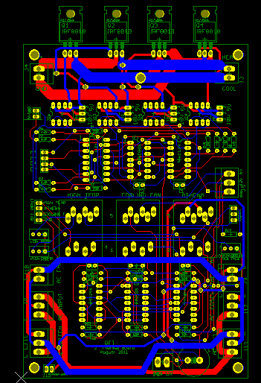
Unit Price | $65 | shipping | Free
Total | $65
Notes/Remarks
- Shipping and banking charges are on buyer’s side
- Price are for from Beijing

Vendor: | 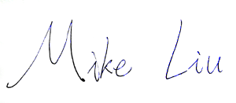 |  | Buyer

